- INTRODUCTION
The main objective of the proposed solution is to be automated the conversion of date. The solution will facilitate to the end user to translate date from BS to AD and AD to BS. This solution is very much necessary for the private sector and the corporate sector. Using the solution the ender user can simply convert date required.

1.1 Purpose and Scope
The purpose of this simple work is to convert date. Since there are always being problem to convert date of birth and other date in day to day while we are in office and other sector, As we all know that in context of Nepal we use both BS as well as AD date in most of forms we need to fill both the field and we get problem in conversion of date , so here is the simple work that convert and resolve the problem in a single click.
The scope of this project is limited. It provide the end user a simple format of date conversion and helps to convert the date

1.2 Model Diagram

END USER
Input BS Date
Input AD Date

Convert

Result Out Put

Fig 1.1 Model diagram for Date Converter
  - Overview
The Date converter simple helps u conversion of date form Nepali date format to English and English to Nepali i.e. BS to AD and AD to BS. This project simply user the mathematical calculation and conversion algorithm for the conversion of date format.
2. System Analysis
2.1 Existing System
In the existing corporate the conversion are done only manually but in proposed system we have to computerize all the conversion using this software helps for the conversion.
2.2 Proposed System
The aim of proposed system is to develop a system of improved facilities. The proposed system can overcome all the limitations of the existing manually conversion system. The system reduces the manual work. The proposed system can be accessed and operated any java platform, as opposed to stand alone or manual system, and provides information at anytime.
2.2.1 Advantage
The following are the advantages of proposed system
- The user can access the system at any time.
- The end user can save time and reduce miscalculation.
- It provides easy to use and user friendly interface for the user.
- Minimum time required
- Better service
- Greater efficiency.
2.2.1 Disadvantage
The following are the disadvantage of proposed system.
- It cannot consider leap year.
- Since the Nepali date has no fixed pattern of days in a month is may also cause error of + or – one day.
- It simply consider each month have 30 days which may not be true in some cases.

3. Software and Hardware Specifications

SOFTWARE REQUIREMENTS
Operating system : windows xp with sp2.
Language (front end) : java (jdk1.5/1.6)

HARDWARE REQUIREMENTS
Processor :Pentium 2. GHz or above
Speed :800 MHz
Hard Disk :80 GB
RAM :512 MB

4. Source Code
import java.awt.*;
import javax.swing.*;
import java.awt.event.*;
import java.applet.*;
import java.util.Date;

public class DateConverter extends JFrame{
//Calander calander=Calander.getInstance();
Date date=new Date();
JButton ADtoBS, BStoAD, Clear;
JTextField year, month, day;
int Y=0,M=0,D=0;
String CY,CM,CD;
JTextField txt;
JPanel p1, p2, p3, p4;

DateConverter(){
JFrame frame=new JFrame();
frame.setLayout(new GridLayout(3,1));
frame.setTitle("Date Conveter");
p1=new JPanel();
p1.add(new JLabel("Welcome! To Date Converter"));

p2=new JPanel();
p2.setLayout(new GridLayout(3, 3));
p2.add(new JLabel("Year"));
p2.add(new JLabel("Month"));
p2.add(new JLabel("Day"));
p2.add(year=new JTextField(10));
p2.add(month=new JTextField(10));
p2.add(day=new JTextField(10));

p2.add(BStoAD=new JButton("BS to AD"));
BStoAD.addActionListener(new ActionListener(){
public void actionPerformed(ActionEvent e){
BStoAD();
}
});

p2.add(Clear=new JButton("Clear"));
Clear.addActionListener(new ActionListener(){
public void actionPerformed(ActionEvent e){
clear();
}
});

p2.add(ADtoBS=new JButton("AD to BS"));
ADtoBS.addActionListener(new ActionListener(){
public void actionPerformed(ActionEvent e){
ADtoBS();
}
});

p3=new JPanel();
p3.add(txt=new JTextField(30));

frame.add(p1,BorderLayout.NORTH);
frame.add(p2,BorderLayout.CENTER);
frame.add(p3,BorderLayout.SOUTH);
frame.setResizable(false);
frame.setVisible(true);
frame.pack();
}

/*....................Funtion for BS to AD...............*/

public void BStoAD(){
getdate();
if(0<D && D<=30 && 0<M && M<=12 && 2000<=Y && Y<=2080){
if(D<=18){
D=(D+30)-17;
M--;
}
else{
D=D-17;
}
if(M<=8){
M=(M+12)-8;
Y--;
}
else{
M=M-8;
}
Y=Y-56;
}
Display();
}

/*....................Funtion for AD to BS...............*/
public void ADtoBS(){
getdate();
if(0<D && D<=30 && 0<M && M<=12 && 1944<=Y && Y<=2024){
D=D+17;
M=M+8;
Y=Y+56;
if(D>30){
D=D-30;
M++;
}
if(M>12){
M=M-12;
Y++;
}
}
Display();
}

public void Display(){
CY=Integer.toString(Y);
CM=Integer.toString(M);
CD=Integer.toString(D);
txt.setText("Converted Date: " +'\n'+Integer.toString(Y)+","+Integer.toString(M)+" , "+Integer.toString(D));
}

public void getdate(){
Y=Integer.parseInt(year.getText());
M=Integer.parseInt(month.getText());
D=Integer.parseInt(day.getText());
if(M<=0 || M>12 || D<=0 ||D>31 || Y<=0){
JOptionPane.showMessageDialog(null, "Invalid Date!");
clear();
}
}

public void clear(){
year.setText("");
month.setText("");
day.setText("");
txt.setText("");
}

public static void main(String[] args){
DateConverter D=new DateConverter();
}
}

5. System Testing
System Testing is a process of executing a program with the explicit intention of finding errors, which cause program failure. There are two general strategies for testing software. They are :
5.1 Code Testing
Code Testing was successfully test with the help of Dr. Java compiler and with the help of flow chart. The error was debugged and still it’s not a final outcome there can be many other bugs that are to be ratify and manipulate using flow chart as follows.
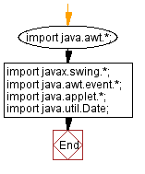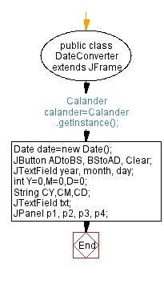

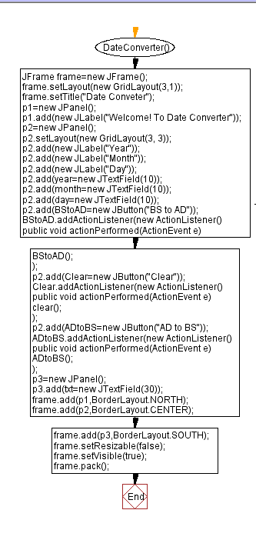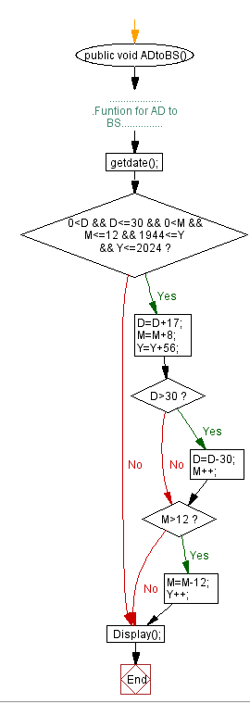
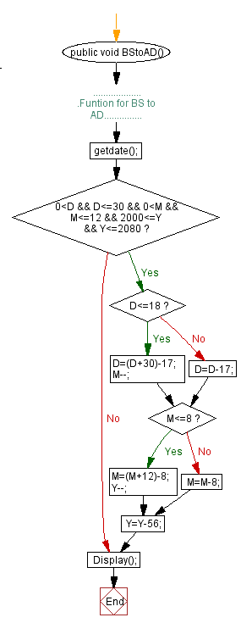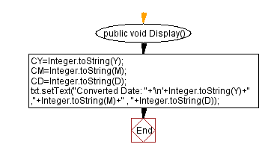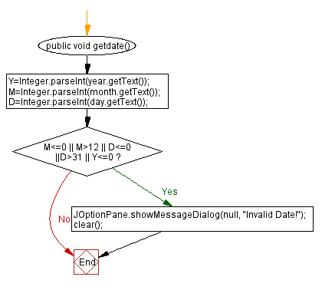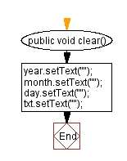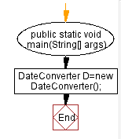

6. Screen shot of Date Converter:
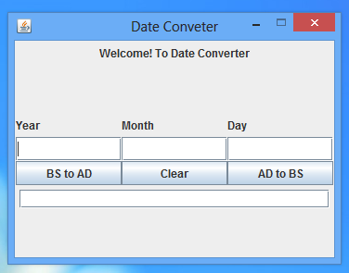
Fig. Screen shot of main frame

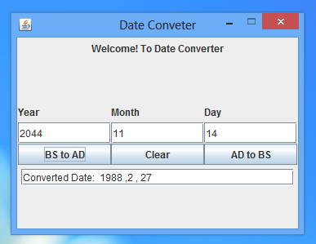
Fig.: Screen shot of BS to AD
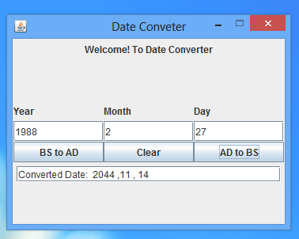

Fig.: Screen shot of AD to BS

7. Conclusion and Feature Encancement
The project titled as Date Converter was deeply studied and analyzed to design the code and implement with various testing methods was done under the guidance of the experienced project guide. The solution developed is free from all the bugs and executable with all different modules to the utmost satisfaction of the end user. All the current requirements and possibilities have been taken care during the project time. We feel that the solution provided now will suit to all the needs end user but also we don’t rule the possibilities of further upgrading of this solution with the new and advance technologies and further additional requirements of the clients.

8. References

http://java.sun.com/docs/books/jls/download/langspec-3.0.pdf

http://en.wikipedia.org/wiki/Java_(programming_language)

